JAVA PROGRAMMING ASSIGNMENT

Experiment-3

Name : Yash Saxena

Branch : IT B (07)

Roll no. : 12213128

Que 1 :

Code :

class Dog{

    public void bark(int x){

        System.out.println("Bark !");

    }

    public void bark(float y){

        System.out.println("Wurf !");

    }

    public void bark(boolean z){

        System.out.println("Bow bow !");

    }

}

public class Que_1{

    public static void main(String args[]){

        Dog tommy = new Dog();

        tommy.bark(5);

        tommy.bark(5.4f);

        tommy.bark(true);

    }

}

Output :

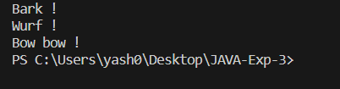

Que – 2

Code :

class student{

    String name = "yash";

    int age = 19;

}

public class Que_2 {

    public static void main(String args[]){

        student a = new student();

        System.out.println("The name of the student is "+a.name);

        System.out.println("The age of the student is "+a.age);

        System.out.println("As there is no error in the programme we can say that default constructor is automatically synthesised");

    }

}

Output :

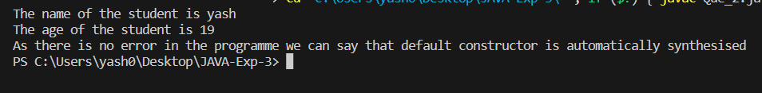

Que – 3

Code :

class student{

    String name;

    int standard;

    int age;

    String gender;

    public student(){

        this("Yash",10,16,"male");

    }

    public student(String a, int b, int c, String d){

        this.name = a;

        this.standard = b;

        this.age = c;

        this.gender = "male";

    }

    public void info(){

        System.out.println("Name :" + name);

        System.out.println("Standard :" + standard);

        System.out.println("Age :" + age);

        System.out.println("Gender :" + gender);

    }

}

public class Que_3 {

    public static void main(String args[]){

        student a = new student();

        a.info();

    }

}

Output :

